INTRODUCTION: Environmental Impact Assessment (EIA)

EIA full form is Environmental Impact Assessment. In simple terms, the meaning of EIA is that it is a process through which an environmental impact of a proposed development is evaluated. While undertaking Environmental Impact Assessment (EIA), the inter-related socio-economic, cultural, and human-health impacts are considered.

What is Environmental Impact Assessments?

It is a process of evaluating the likely environmental impacts of a proposed project or development, taking into account inter-related socio-economic, cultural, and human-health impacts, both beneficial and adverse. EIA is a tool used to assess the positive and negative environmental, economic, and social impacts of a project. This is used to predict the environmental impacts of a project in the pre-planning stage itself so that decisions can be taken to reduce the adverse impacts.

Evolution & History of EIA

EIA is termed as one of the best policy innovations in the 1900s. The main aim of EIA is to conserve the environment and bring out the best combination of economic and environmental costs and benefits. Read the below-mentioned points to understand the Environmental Impact Assessment evolution and history:

1. The birth of EIA is dated back to the 1970s. In 1969, The USA had brought its first National Environment Policy Act (NEPA) 1969.
2. The EIA was initially practised by developed nations but slowly it was also introduced in developing nations including India.
3. Columbia and the Philippines are the earliest examples of developing nations who introduced EIA in their policies. Columbia brought it in 1974 while the Philippines in 1978.
4. Worldwide, EIA is now practised in more than 100 countries. By the mid-1990s, some 110 countries applied EIA as a major environmental policy.
5. In 1989, EIA was adopted as the major development project by the [World Bank](https://byjus.com/free-ias-prep/world-bank-group/).

Check the image below to have an idea of major developments around Environmental Impact Assessment in history:

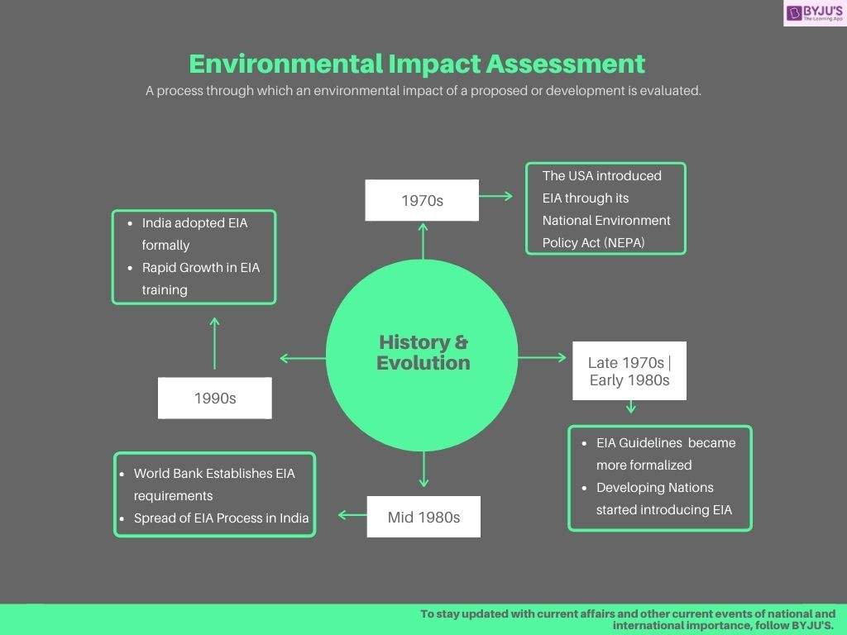

Objectives of Environmental Impact Assessment

1. Identifying, predicting, and evaluating economic, environmental, and social impacts of development activities.
2. Providing information on the environmental consequences for decision making.
3. Promoting environmentally sound and suitable development by identifying appropriate alternatives and mitigation measures.

Environmental Impact Assessment (EIA) Process

The table below will mention the EIA Process in brief:

|  |  |
| --- | --- |
| **Environmental Impact Assessment (EIA) Process** | |
| **Process** | **Details in Brief** |
| Screening | Which projects need a full or partial assessment study is decided in this stage |
| Scoping | * Which impacts are necessary to be assessed is decided in this stage. While doing so, legal requirements, international conventions, expert knowledge, and public engagement are also considered. * Alternative solutions that avoid or at least reduce the adverse impacts of the project are also studied in this stage * Investigation of alternate designs or sites that avoid or mitigate impact takes place |
| Assessment & Evaluation of Impacts and Development of Alternatives | Environmental impacts of the proposed project are analyzed and light is thrown upon the alternatives present to such projects |
| EIA Report also called Environmental Impact Statement (EIS) | An environmental management plan (EMP) and also a non-technical summary of the project’s impact is prepared for the general public in this stage |
| Decision Making | The fate of the project is decided. Whether the project is to be given approval or not and if it is to be given, under what conditions |
| Monitoring, compliance, enforcement and environmental auditing | Monitoring whether the predicted impacts and the mitigation efforts happen as per the EMP |

Importance of Environmental Impact Assessment

1. EIA is a good tool for prudent environment management.
2. It is government-policy that any industrial project in India has to secure EIA clearance from the Environment Ministry before approval for the project itself.

Current EIA Reports – India

EIA Notification 2020 draft has been made public. Once the EIA Notification 2020 will be published in the Official Gazette, it will replace EIA notification 2006. EIA has been in the news following EIA notification 2020 was drafted as one of the amendments will be the removal of public consultation from several activities (Put under Category B2).

Here are a few important terms/agencies concerning EIA notification 2020.

1. Accredited Environment Impact Assessment Consultant Organization (ACO)
2. [Central Pollution Control Board](https://byjus.com/free-ias-prep/central-pollution-control-board-cpcb/)
3. Certificate of Green Building
4. Corporate Environment Responsibility
5. Eco-Sensitive Area/ Eco-Sensitive Zone

Environmental Impact Assessment In India

* EIA started in India in 1976-77 when the Planning Commission directed the Department of Science & Technology to assess the river valley projects from the point of view of the environment. This was extended for all those projects that required approval from the Public Investment Board.
* Then, in 1986, the government enacted the Environment (Protec­tion) Act which made EIA statutory. The other main laws in this regard are the Indian Wildlife (Protection) Act (1972), the Water Act (1974), the Air (Prevention and Control of Pollution) Act (1981), and the Biological Diversity Act (2002).
* In 1982, the Ministry of Environment, Forest and Climate Change set up the **Environmental Information System (ENVIS) to collect, collate**, storing, retrieving and disseminating information related to the environment sector. This serves as a web-based distributed network of subject-specific databases. The chief purpose of the ENVIS is to integrate all countrywide efforts to collect, store, disseminate, and use environment-information for better managing environmental assessment activities.